Data Mining Proposal
Job-hopping or Job-Hugging, what brings in top talent and makes them stay
Team Solo Pilotbear
Project midterm review
Date: April 12, 2026

In this project, we are interested in utilizing data analytics approach in discovering the science behind employee attrition at workplace, levering binary classification algothrims, employ machine learning such as FP-growth techniques to identify the secret sauce of what makes employee stay and turnover.

Let us first look at a simple analysis and see, at the raw data level, how overtime can impact the employee attrition. It turns out, consistently overtime is a driver to make the employee rethink the employment and push to make changes. Employees that have consistently experienced overtime are 3 times more likely to leave than their peers that do not.

As a business, overtime can happen, we understand that sometimes a project, a presentation, or an urgent meeting can take place. However, employers should not make a habit out of this; overtime should be exceptions, in extraordinary circumstances, and rarely utilized. Please make “on-time” the overwhelmingly expectation and experience, and your employees is more likely to stick around and share the growth together.

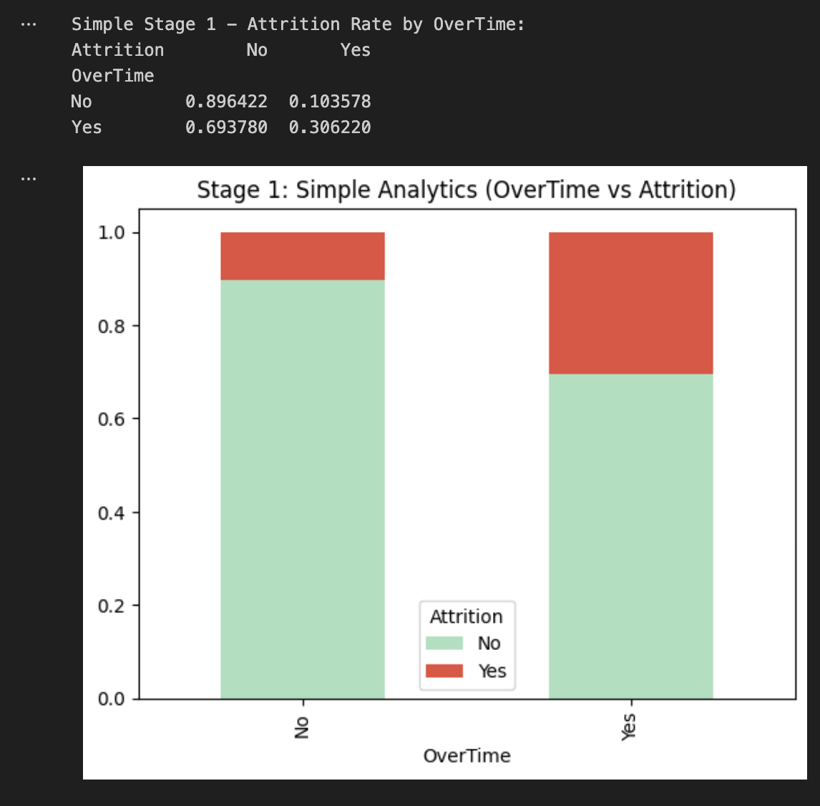

Next up, we have more detailed analysis that goes beyond one simple factor “overtime”. We take into account a number of varibles and is able to pick the top 5 that mattered the most:
Monthly Income, the higher the income the more likely the employee to stay, this is true not only because of the monetary rewards to the employee, it also indicates that, as the knowledge, experience, and expertise grow, the employee is moving to a niche marketplace and is harder to find an exact position that requires the exact skillsets. It also indicates that the number of openings shrinks as the employee progresses.
Age plays a significant part too. Young professionals (age < 30) has a higher mobililty, for a number of reasons:
They are in the early stages of finding out what they are good at and is hungry for promotions. In some areas and some times, job hopping rewards the early-stage careers to change the job, at a higher frequency. Another reason is that, young people are more likely to not be bounded by family, they have a great mobility in the workplace.
Overtime, as we covered in the last section, plays a big part too. And we will not repeat ourselves here.
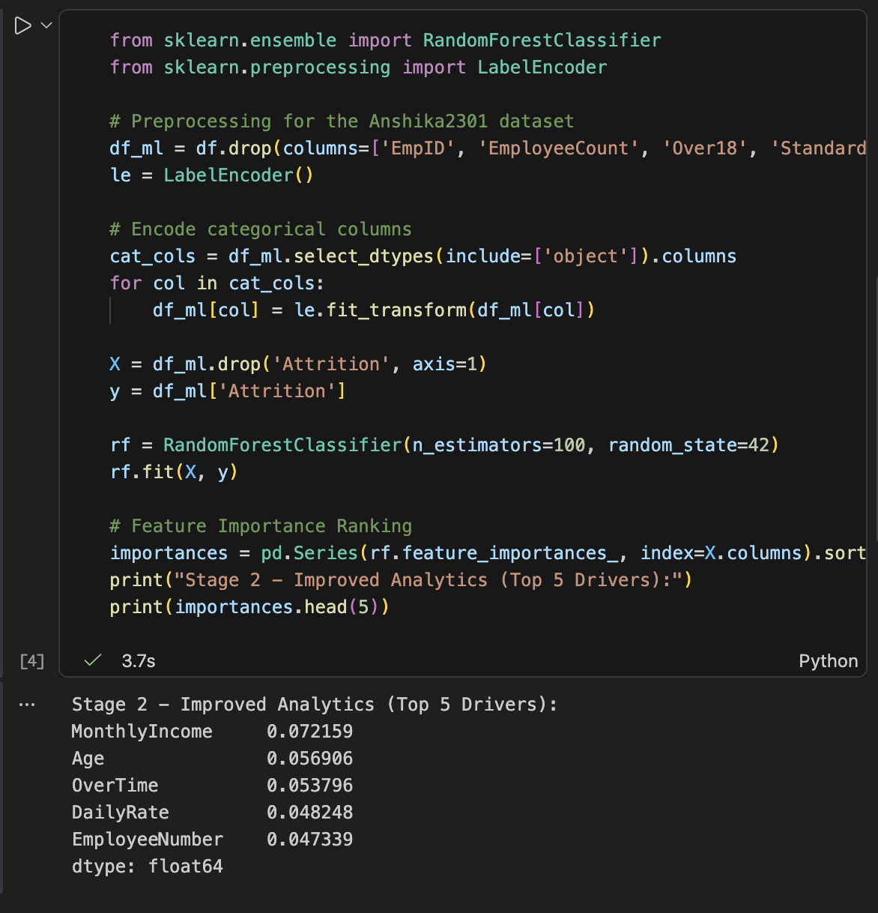
We now turn our attention to association rules that go beyond classficiation. We can see employees who work overtime, and has Low monthly income, and are single are more likely to attrition than their peers.
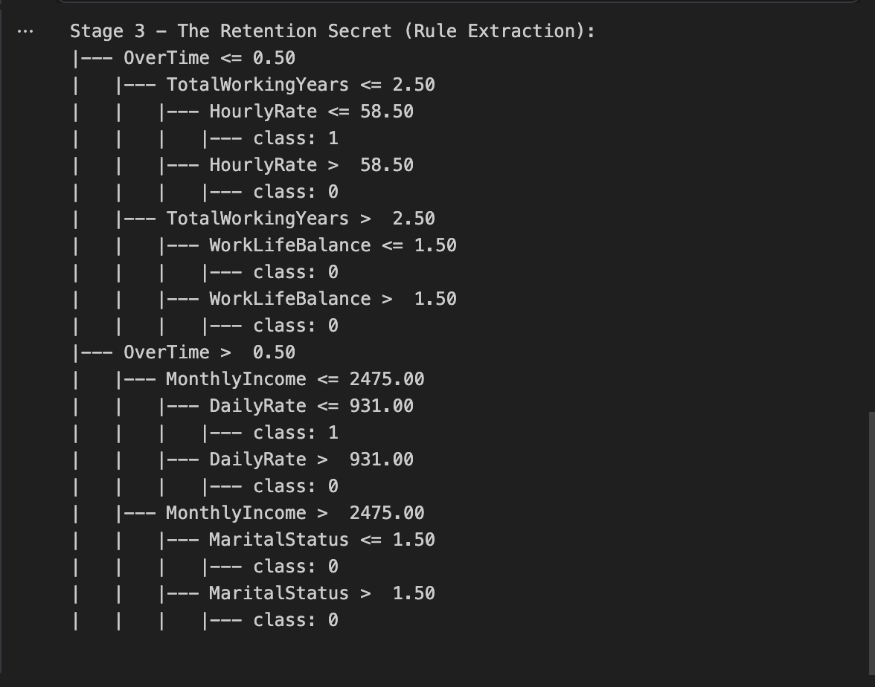

Some of the problems and future directions: I tried to implect Aprior and FP-growth into the analysis but it is little more tricky than I anticipated and is currently working on resovle the issues. Hopeful to be able to produce the results soon.
A back testing schema has been attempted however, the results do not align with my hypothesis and thus, I believe I may have inputted it wrong. More time may be needed in this case and hopefully I can get the code to work shortly.
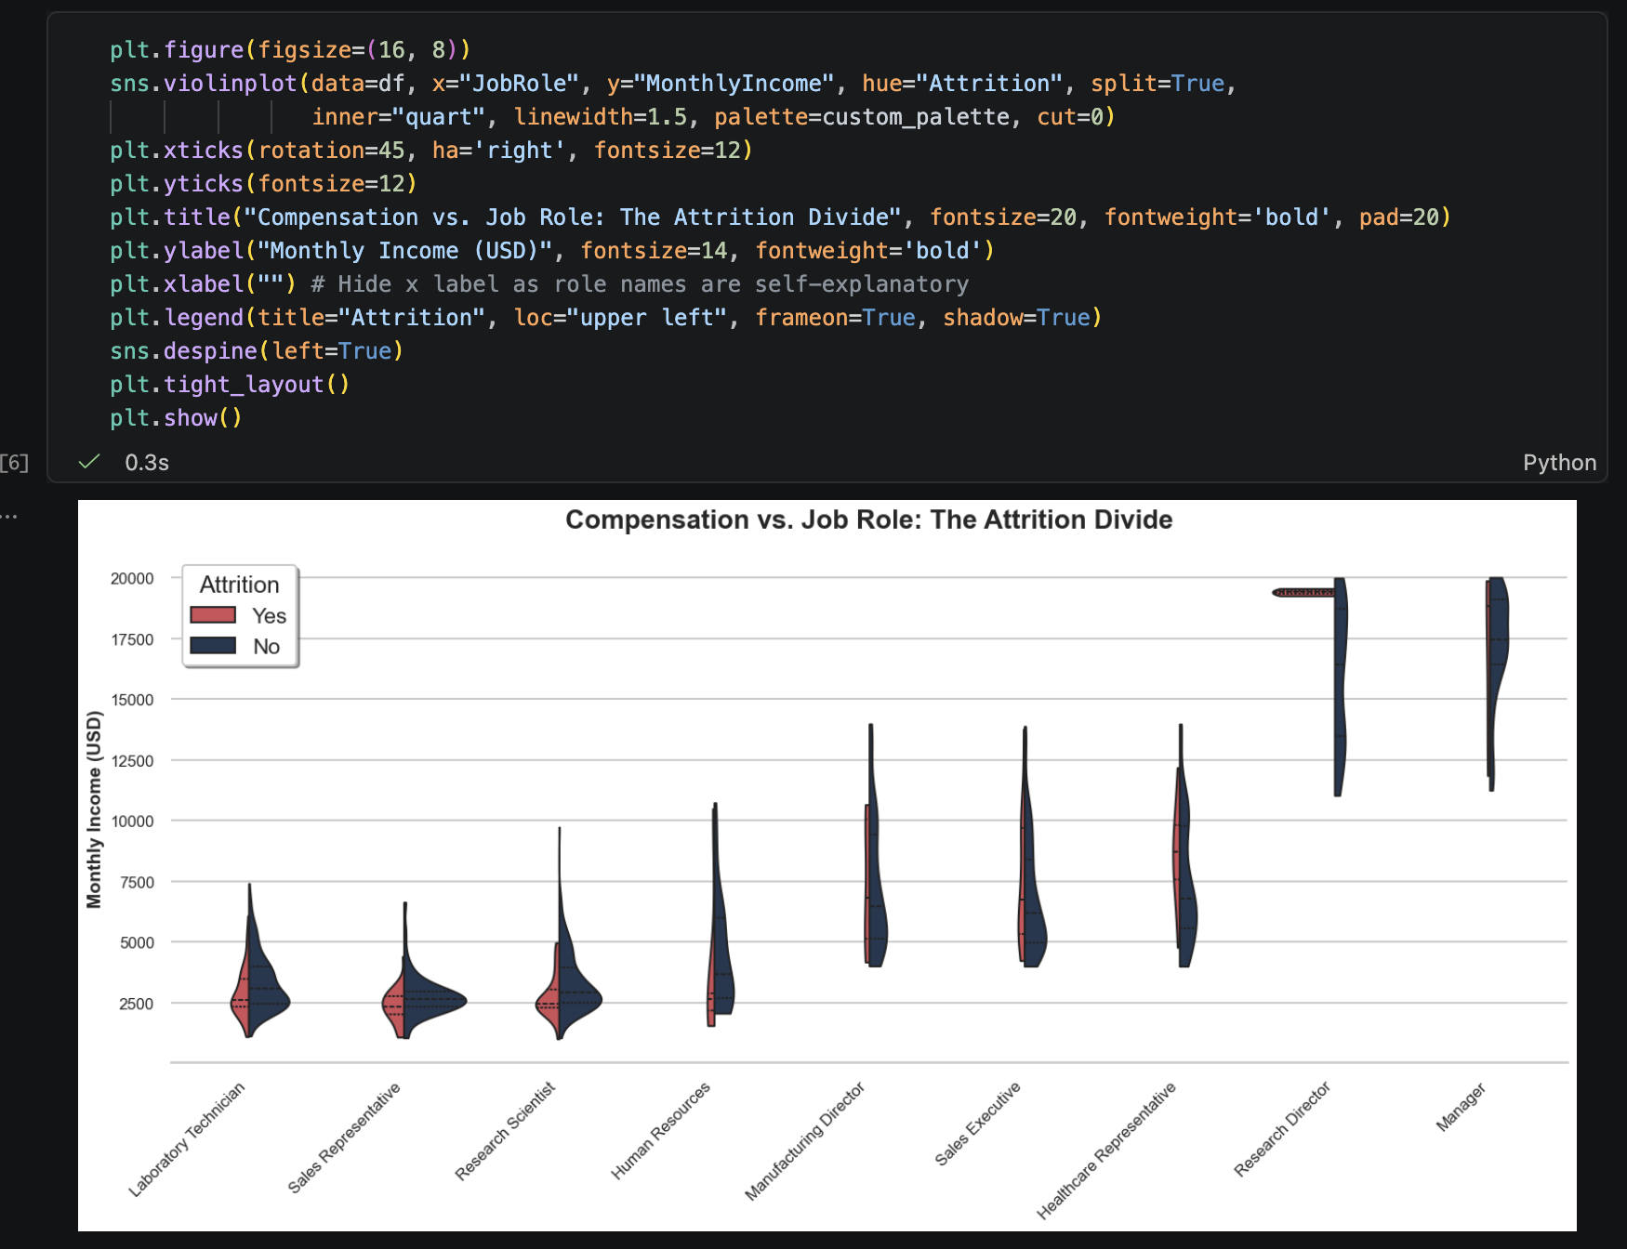

We take a closer look at the compensation landscape, this easy-to-ready violin plot among different jobs to see who left and who stayed. We can see a clear trend that, among lower pay for the positions, regardless of job types, employees are more likely to leave, indicting a lower pay has a higher turn-over rate.

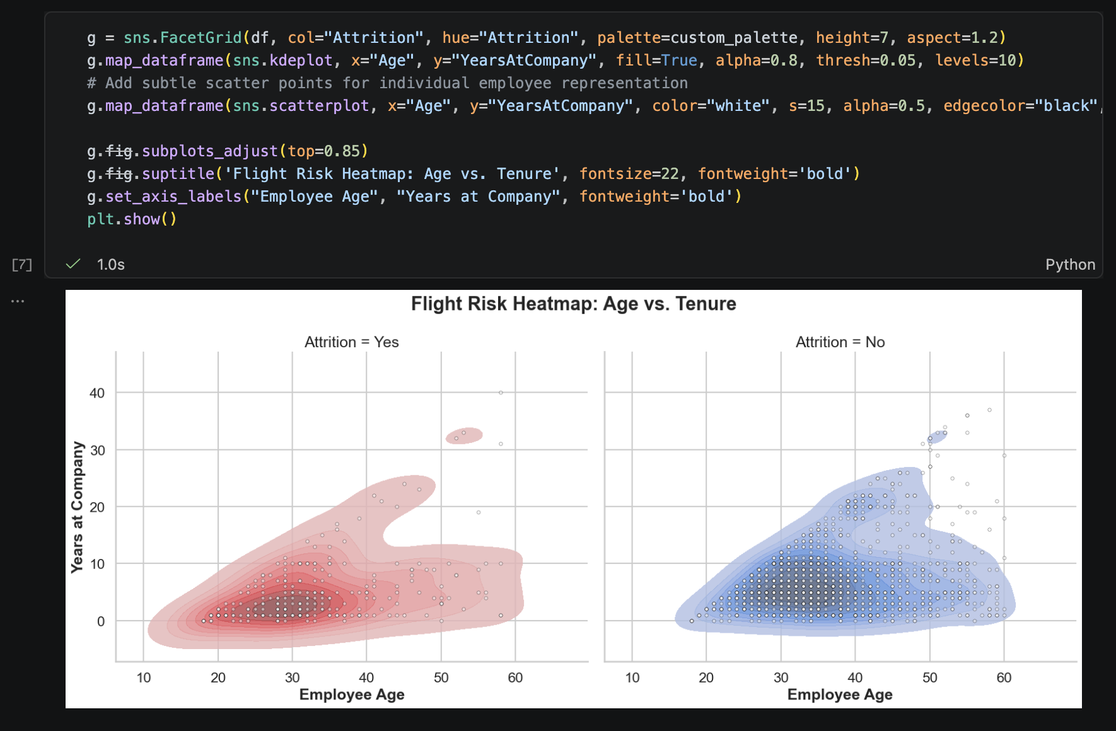
We then turn our attention to the flight risks. In this heatmap, we can see the concertation is among the younger employees, in 20s and 30s. Their short tenure 1-3 years may have correlated with the accelerating of economy at the time, so more study is needed, suggesting, at the period, job-hopping is more rewarding for the early career candidates. However, the persistent inflation and cooling job-market of recent years might have shifted the this trend. Thus, a renewed study is needed.

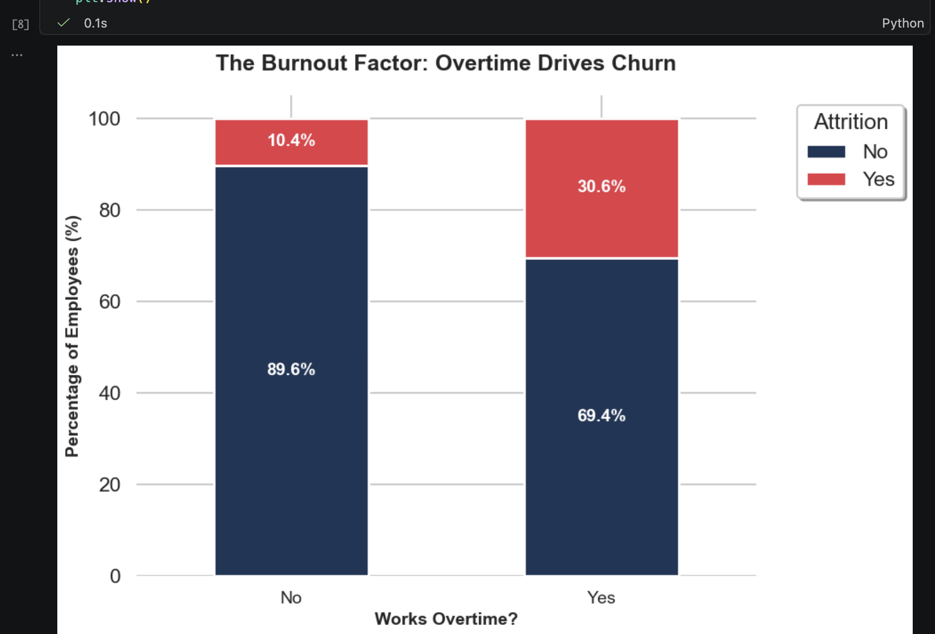

In this easy-to-read and easy-to-understand bar chart, we can clearly see how burnout affects employees. Work overtime contribute significantly to employees’ burn out and leading to much higher chance of leaving the job. So this is reminder to the employers to not to over work your employees and give them the ecstaticity and flexibility in the daily work routine.
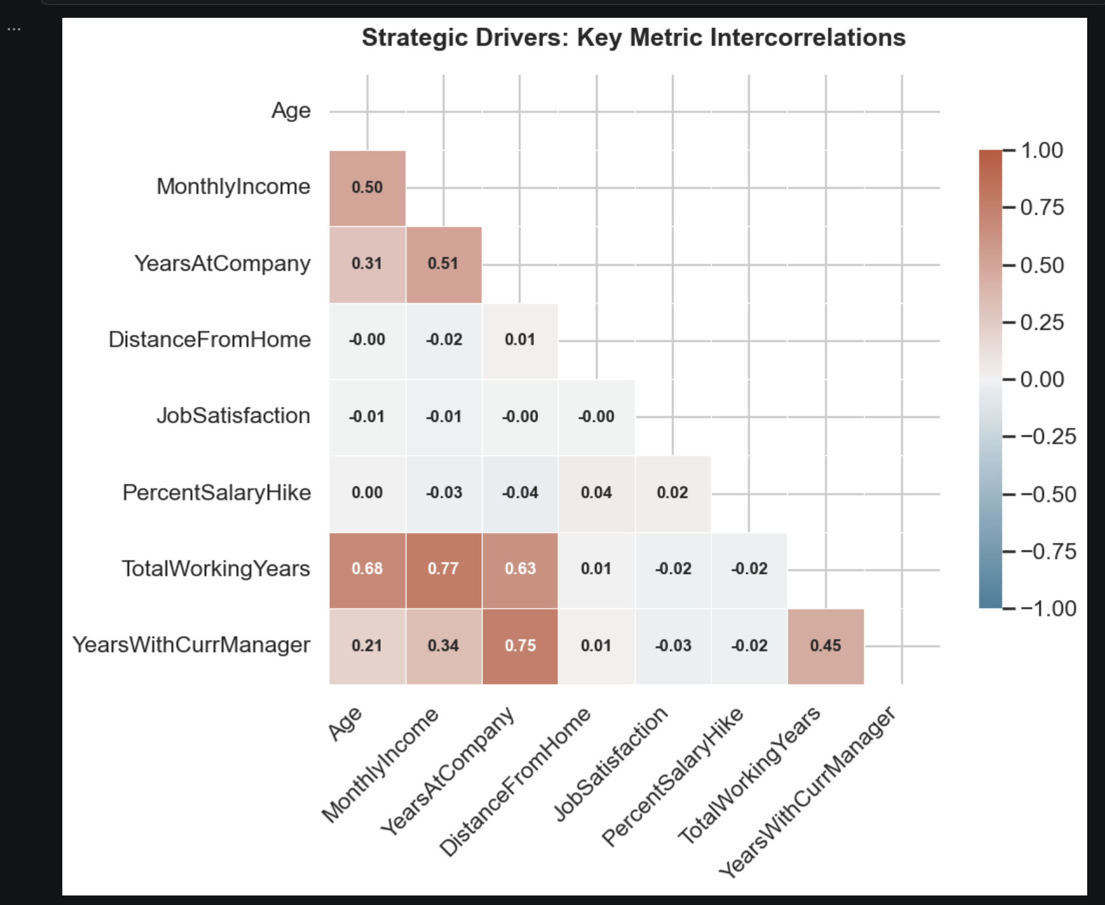

In this correlation matrix, we show the relations among many key variables. While total working years and monthly income are highly correlated, some are not. A key point is the Distance from Home, is acting indecently of other factors, which suggests that, even with a higher pay, commute stress cannot be “bought off”. And this should plant a key idea among HR professionals.

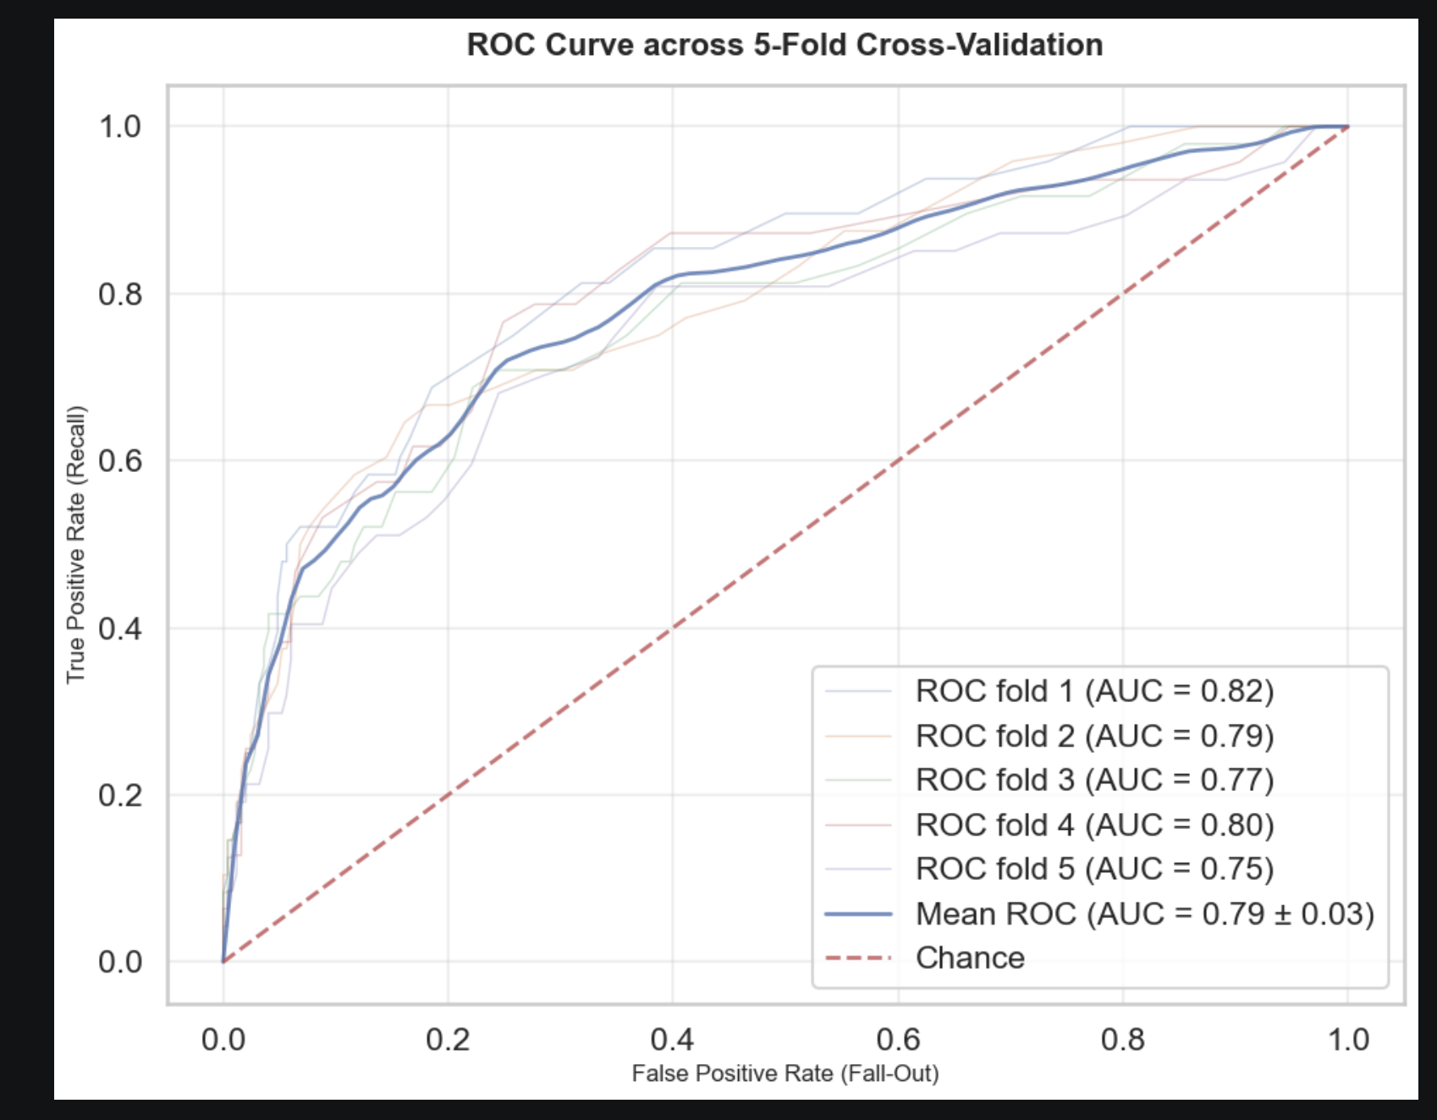
For back-testing, we elected to use 5-fold Cross-validation and separate our dataset into 4 parts of training data and one part of ‘unseen’ testing data.
Here are the results:
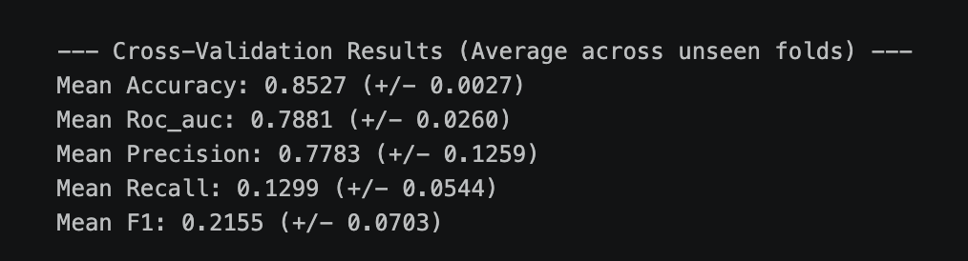
Our model predicts bery well, ROC-AUC score averaged 0.79, and it proves that core impactors, such as pay equity, overtime, and tenure are strong movitives among all job candidates; however, our model measures short in some of key areas too.
Our model is conservative on prediction, it has a high precision, meaning when it flags a candidate, that candidate is likely to quite, 3 over 4 times in correct identifying. It has a low recall score of only 12%, meaning it only flags about 12% candidate that ended up leaving the positions.

For future directions, we will need to lower the threshold to flag more potential job-hoppers for HR to use. Currently, the threshold is too high and too restrictive and would not be an ideal tool to improve the employee ratification.
I have learned a lot of data mining, data analytics, visualization in this class. I am more confident now to utilize different ML algorithms to find the hidden patterns.
Thank you for another great semester and I look forward to learning and working alongside with all of you. Thank you.

